SIMATS ENGINEERING
ASSESSMENT TOOL 2

COURSE NAME: INTERNET PROGRAMMING
COURSE CODE: CSA43

COURSE OUTCOME COVERED

CO-4: Formulate data-driven web solutions using XML, XSLT, and JSP within the MVC framework. (L4)

Assessment Tool : Pseudocode Writing Task (Algorithm Design)
Weightage: 20%

QUESTIONS: Total Marks: 25

1: XML Parsing Algorithm
Write a detailed pseudocode algorithm to parse an XML document that contains structured data such as user or product details. Your algorithm should clearly describe the steps involved in loading the XML file, accessing its elements, traversing through nodes, extracting required data, and displaying the output in a readable format. Ensure that the logic handles hierarchical structure properly.

2: MVC Workflow
Write a pseudocode representation of the MVC (Model–View–Controller) workflow in a web application. Your answer should clearly illustrate how a user request is received, processed by the Controller, how the Model interacts with the database, and how the View generates and returns the response to the user. Include all major steps involved in request handling and response generation.

3: JSP Request Flow
Write a detailed pseudocode algorithm to explain the request–response flow in a JSP-based web application. Your algorithm should include steps such as client request initiation, server processing, interaction with backend components (like Servlets or database), and generation of dynamic content that is sent back to the client.

4: Database Retrieval
Write a pseudocode algorithm to retrieve data from a database. Your answer should include steps for establishing a database connection, executing SQL queries, processing the result set, and displaying the retrieved data. Clearly represent the sequence of operations involved in database interaction.

5: PHP Validation
Write a pseudocode algorithm for validating user input in a web form using PHP concepts. The algorithm should include checks for empty fields, validation of input formats (such as email and password), handling invalid inputs with appropriate error messages, and allowing submission only when all validations are satisfied.

Code of Conduct:

I G.CHAKRADHAR(192311439) certify that this submission is my original work and that I have adhered to the guidelines specified for this assessment.
I understand that any violation of academic integrity rules will result in disciplinary action.

Signature of the student:

RUBRICS FOR CALCULATION:

Criteria | Weightage | Level 4 – Exemplary | Level 3 – Proficient | Level 2 – Developing | Level 1 – Beginning
Problem Understanding | 20% | Identifies all inputs, outputs, constraints accurately | Minor missing elements | Partial understanding | Incorrect interpretation
Algorithm Design | 30% | Complete, correct, and logically sound solution | Minor logical gaps | Partially correct logic | Incorrect approach
Use of Control Structures | 20% | Efficient and appropriate use of loops, conditions, functions/modules | Minor inefficiencies | Limited or basic usage | Incorrect or missing constructs
Pseudocode Structure | 10% | Well-structured, clear, consistent format, easy to follow | Mostly clear with minor issues | Difficult to follow in parts | Poorly structured and unclear
Completeness | 20% | Handles all cases; optimized approach | Handles most cases; reasonable efficiency | Handles basic cases only | Incomplete or inefficient

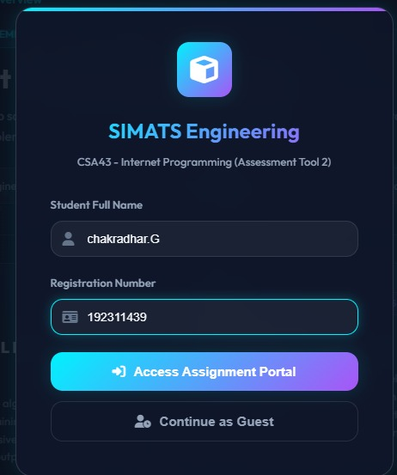

Question-1:

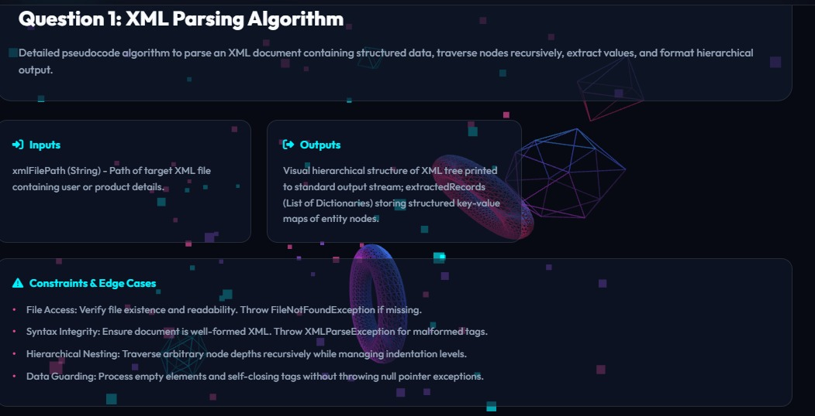

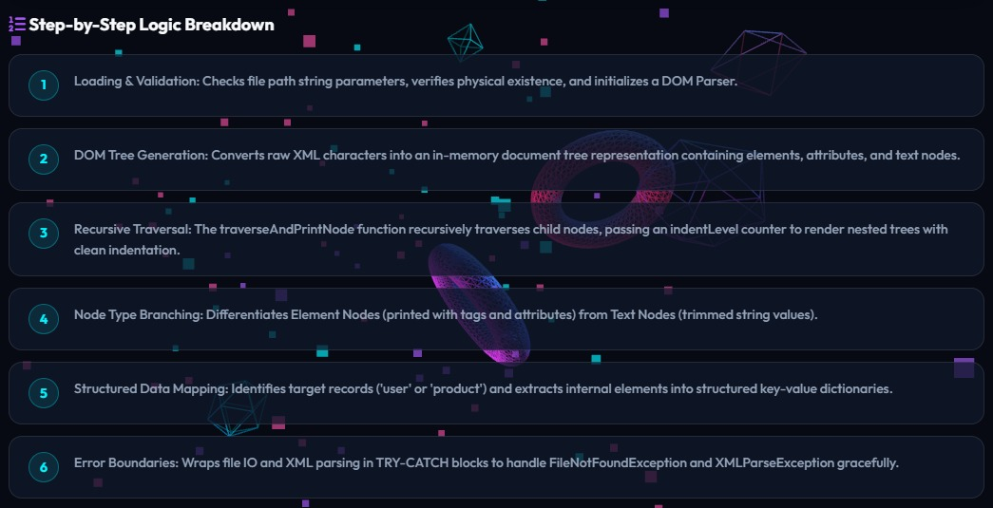

Question-2:

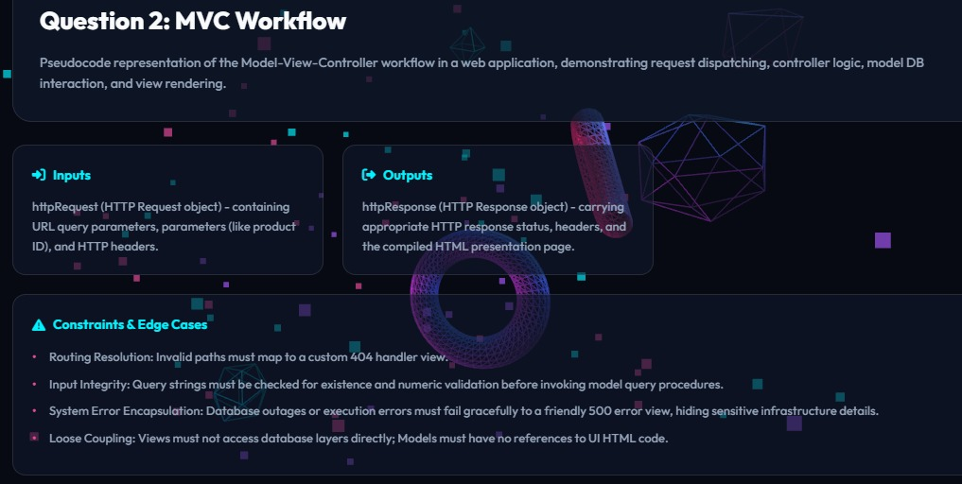
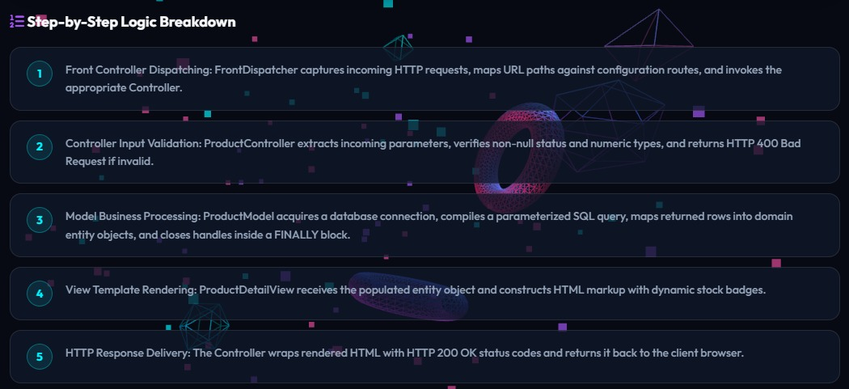

Question-3:

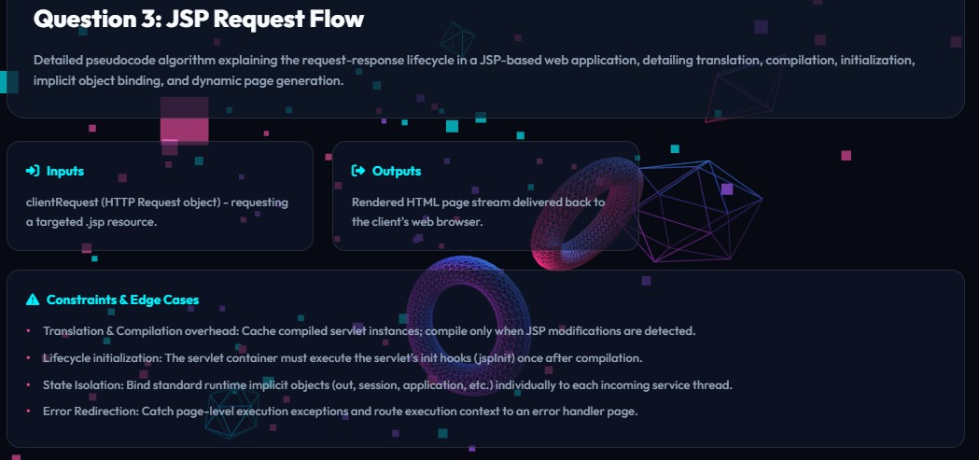

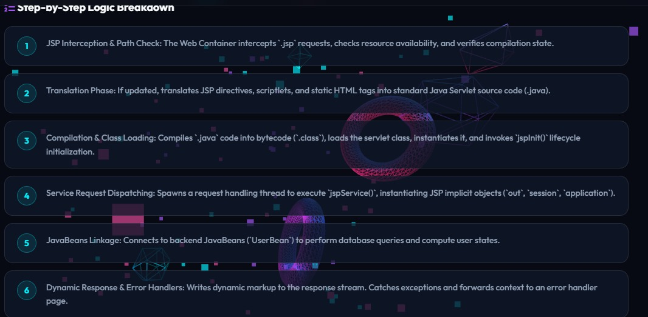

Question-4:

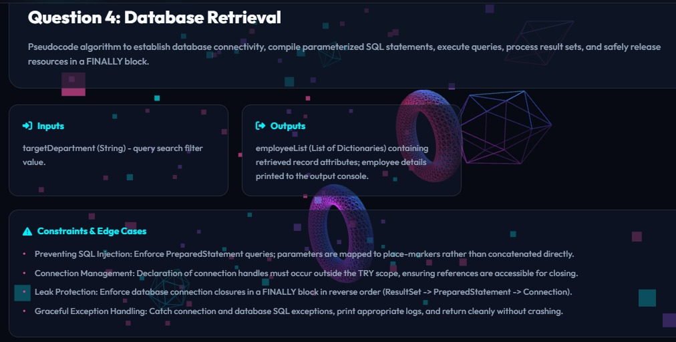

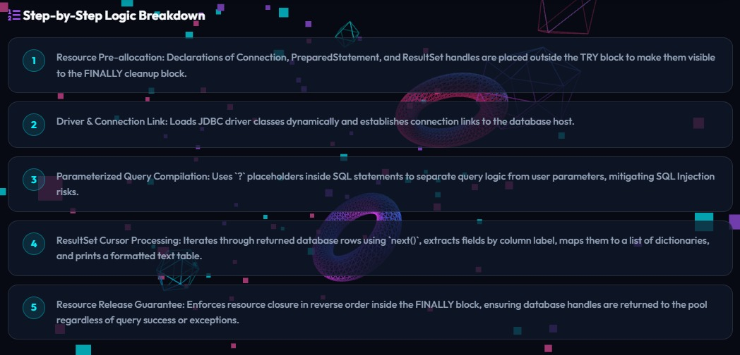

Question-5:

